DAY-2

CLASSWORK

1. John is building a simple website for a greeting card company, and you want to create a React component that displays a "Hello, World!" message. How would he implement this functionality in the React app.

CODE:

import React from 'react';

// Define the HelloComponent

const HelloComponent = () => {

return (

<div>

<h1>Hello, World!</h1>

</div>

);

};

// Export the component for use in other parts of the app

export default HelloComponent;

OUTPUT:

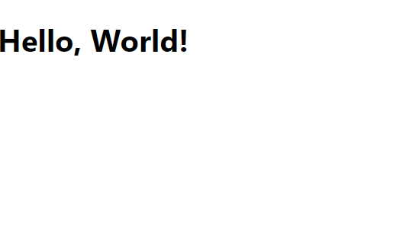

2.BUILDING INLINE CSS:

CODE:

import React from 'react';

const App = () => {

const divStyles = {

backgroundColor: 'lightblue',

color: 'darkblue',

padding: '10px',

border: '1px solid blue',

borderRadius: '5px',

};

const paragraphStyles = {

color: 'darkblue',

fontSize: '16px',

};

const headingStyles = {

color: 'green',

};

return (

<div style={divStyles}>

<h1 style={headingStyles}>Inline Style in JSX Example</h1>

<div>

<p style={paragraphStyles}>This is a paragraph with inline styles applied.</p>

</div>

</div>

);

};

export default App;

OUTPUT:

